//\*\*\*\*\*\*PREREQUISITE STEPS FOR INSTALLATION\*\*\*\*\*\*\*\*//

1) Create EC2 instances on AWS & modify the security group.

Modify inbound & outbound rules :-

Add new rule for Type "All traffic" & source "Anywhere IPV4", check line 3.

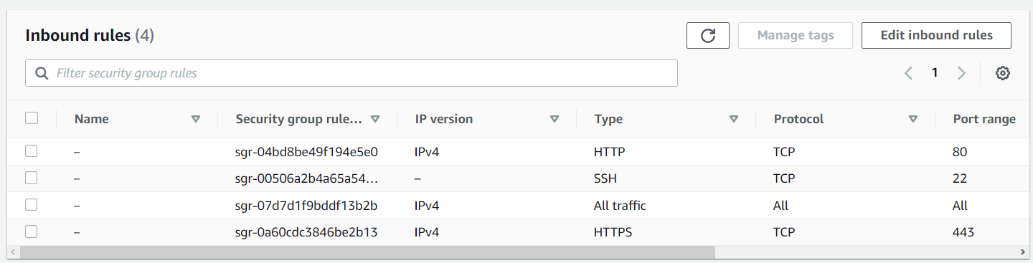

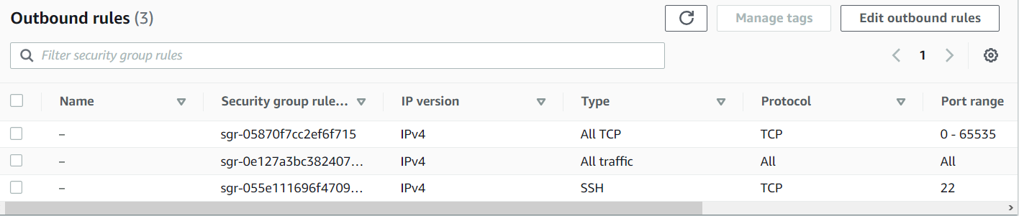

Rename EC2 instances by below commands & re-login into VM’s.

sudo hostnamectl set-hostname nagios-server

sudo hostnamectl set-hostname host1

2) Additionally set timedate on server & host.

sudo timedatectl set-timezone Asia/Calcutta

Check the time on server to verify by date command.

date

3) Install firewall for RHEL, by default it's not present in RHEL 9.x.x. Do this for both host & server.

yum install firewalld -y

Next enable & start the firewall by below commands,

sudo systemctl enable firewalld

sudo systemctl start firewalld

4) Give the public IP addresses for host & server in the hosts file,

vi /etc/hosts

add the IP address and follow this step on both server & host.

5) Check if SELINUX is permissive or enforcing. Needs to be enforcing on server & host.

Use getenforce and sestatus command check for current mode, if enforcing change to permissive by below command.

sed -i s/^SELINUX=.\*$/SELINUX=permissive/ /etc/selinux/config && setenforce 0

Then verify by using getenforce && sestatus if they are showing permissive.

6) Update both host & server by below command.

dnf update -y